CCP PROJECT

SCIENTIFIC CALCULATOR PROJECT REPORT

Developed in C Language

Submitted by:

Group Members:

- Ahmed Rashid CT-25079 – Project Lead / Coding

- GHULAM Rasool CT-25082 - Documentation Writer

- WALEED Irfan CT-25099 - Logic & Testing

Course Name and Code:

Programming Fundamental – CT-175 PF

Instructor Name: Sir. Muhammad Abdullah

Institute Name: N.E.D University
Session: Fall 2025

Date of Submission: 10-11-2025

Index

Introduction

Objective
- Scope of Project
- Programming Language and Header Files
- Logic and Working
- Functions Used

Flow of Execution

Flowchart

Code
- Dry Run Example
- Sample Output
- Conclusion

1.INTRODUCTION:
The Scientific Calculator is a commonly used digital tool that enables users to perform a wide variety of mathematical operations with precision and speed. This project demonstrates how a simple command-line calculator can be implemented using the C programming language. The calculator allows users to select operations from a menu and perform computations interactively. C language provides the essential tools for implementing algorithms and data manipulation at a low level, making it ideal for learning fundamental computational logic. This project serves as an introduction to procedural programming concepts such as modularity, user input/output, loops, and control flow. The calculator allows users to choose from multiple operations through a menu-driven interface, making interaction simple and user-friendly.
The program is capable of performing both basic arithmetic operations—such as addition, subtraction, multiplication, and division—and advanced mathematical functions, including power calculation, factorial computation, and square root determination. Each operation is implemented using a separate function, showcasing the concept of modularity in C programming. This design approach not only improves readability but also makes the code easy to maintain and extend.
The project effectively utilizes loops, conditional statements, and function calls, providing a strong foundation for understanding procedural programming in C. The use of libraries like <math.h> demonstrates how built-in mathematical functions can simplify complex calculations. Error handling has also been considered, ensuring that operations such as division by zero or square roots of negative numbers are properly managed.
Through this project, learners can gain practical experience in structured programming, algorithm development, and debugging. It serves as an excellent example of applying core programming principles to solve real-world computational problems. Overall, the Scientific Calculator Project offers a clear and practical introduction to the capabilities of the C language in creating efficient, logical, and user-interactive software.

2.Objective:
The objective of this program is to design a menu-driven scientific calculator using the C programming language that performs basic and advanced arithmetic operations such as:
- Addition
- Subtraction
- Multiplication
- Division
- Power
- Factorial
- Square Root
The program continues to run in a loop until the user chooses the option to exit, allowing multiple calculations in a single session. It is designed to provide accurate results and a simple, user-friendly interface for performing complex mathematical computations efficiently.
This project also aims to strengthen the understanding of core C programming concepts, including modular programming, loops, conditional statements, recursion, and the use of built-in library functions like <math.h>. By implementing this calculator, learners can develop logical thinking, improve their problem-solving skills, and gain practical experience in designing real-world applications through structured programming.

3. Scope of the Project:
This project focuses on developing a menu-driven scientific calculator that provides users with a simple yet effective tool for performing various mathematical operations. The program highlights the application of core C programming concepts in building a functional, real-time computational system.
The scope of this calculator extends beyond basic arithmetic. It includes advanced operations such as power calculation, factorial computation, and square root evaluation, making it useful for both academic and practical purposes. The design emphasizes a user-friendly interface, modular structure, and accurate handling of mathematical expressions.
In addition to its current capabilities, the project can be expanded in the future to include trigonometric, logarithmic, and other scientific functions. It may also be adapted to feature a graphical interface for improved usability.
Overall, this project demonstrates how simple programming logic can be used to develop effective digital tools. It serves as a foundation for students and learners who wish to explore more complex applications and enhance their understanding of programming-based problem solving.

4.Programming Language and Header Files:
The Scientific Calculator Project is developed using the C programming language, which is widely known for its speed, flexibility, and strong support for mathematical and logical operations. C provides the fundamental tools needed for building efficient and structured programs, making it an ideal choice for implementing a command-line calculator.
The project makes use of standard C header files to support input/output operations and mathematical computations. These header files provide access to predefined functions that simplify complex programming tasks.
Programming Language:
- C Language
Header Files Used:
- #include <stdio.h> — This header file is used for performing standard input and output operations such as displaying messages on the screen using printf() and taking user input with scanf().

- #include <math.h> — This header file provides mathematical functions such as pow(), sqrt(), and other advanced operations that enable the calculator to perform scientific calculations efficiently.

5.Logic and Working:
The program uses a menu-driven approach that allows users to select different mathematical operations through a simple numeric menu. The logic of the program is based on conditional statements and looping structures that ensure smooth execution and continuous interaction with the user.
The working of the program can be summarized as follows:
- The user is presented with a menu of operations, each assigned a number (1–8).
- The user selects the desired operation by entering the corresponding number.
- Based on the user’s choice, the program prompts for the required input values.
- Each operation (addition, subtraction, multiplication, division, power, factorial, and square root) is handled by a separate function, ensuring modularity and code reusability.
- After performing the operation, the result is displayed on the screen.
- The loop continues to run, displaying the menu again, until the user selects option 8 (Exit) to terminate the program.

6.Functions Used:

Several user-defined functions have been incorporated into the calculator to perform different mathematical operations independently. Each function focuses on a specific task, improving the structure, readability, and reusability of the code. The use of functions also helps in dividing the program into smaller logical parts, making debugging and future updates easier.
Function |  | Purpose
add(float a, float b) |  | Computes and returns the sum of two numbers.
subtract(float a, float b) |  | Finds the difference between two given numbers.
multiply(float a, float b) |  | Calculates the product of two numbers.
divide(float a, float b) |  | Returns the quotient after division while checking for division by zero.
power(float base, float exp) |  | Determines the result of a base raised to an exponent using the pow() function from <math.h>.
factorial(int n) |  | Computes the factorial of an integer using recursion.
Square Root(float n) |  | Finds the square root of a given number using the sqrt() function from <math.h>.

7.Flow of Execution (Step-by-Step):
- Start the Program
  - Display a menu with 8 options for different mathematical operations.
- User Input
  - The program reads the user’s choice using scanf("%d", &choice);.
- Switch Statement Execution
  - Depending on the value of choice, the control goes to the relevant case.
- Perform the Operation
  - The program takes the required inputs (one or two numbers).
  - Calls the corresponding function to perform the operation.
- Display the Result
  - Prints the result of the calculation using printf().
- Repeat / Exit
  - After displaying the result, the program loops back to the main menu.
  - The program repeats until the user enters 8 (Exit)

8.PROGRAM FLOWCHART:
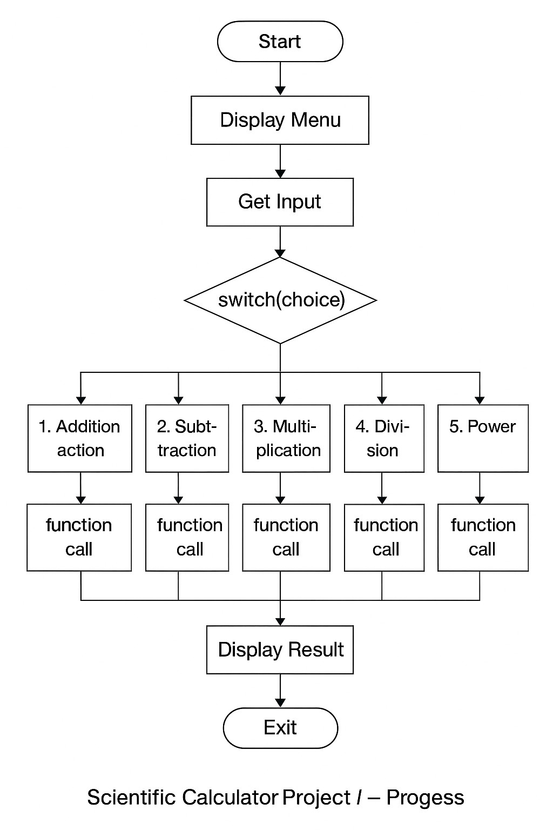

CODE:

#include <stdio.h>

#include <math.h>

float add(float a, float b);

float subtract(float a, float b);

float multiply(float a, float b);

float divide(float a, float b);

float power(float base, float exp);

long long factorial(int n);

float squareRoot(float n);

int main() {

int choice;

float num1, num2;

int n;

while(1) {

printf("\n==== Scientific Calculator ====\n");

printf("1. Addition\n");

printf("2. Subtraction\n");

printf("3. Multiplication\n");

printf("4. Division\n");

printf("5. Power\n");

printf("6. Factorial\n");

printf("7. Square Root\n");

printf("8. Exit\n");

printf("Enter your choice: ");

scanf("%d", &choice);

if(choice == 8){

printf("Exiting... Bye!\n");

break;

}

switch(choice){

case 1:

printf("Enter two numbers: ");

scanf("%f %f",&num1,&num2);

printf("Result = %.2f\n", add(num1,num2));

break;

case 2:

printf("Enter two numbers: ");

scanf("%f %f",&num1,&num2);

printf("Result = %.2f\n", subtract(num1,num2));

break;

case 3:

printf("Enter two numbers: ");

scanf("%f %f",&num1,&num2);

printf("Result = %.2f\n", multiply(num1,num2));

break;

case 4:

printf("Enter two numbers: ");

scanf("%f %f",&num1,&num2);

if(num2==0)

printf("Error: Can't divide by zero!\n");

else

printf("Result = %.2f\n", divide(num1,num2));

break;

case 5:

printf("Enter base and exponent: ");

scanf("%f %f",&num1,&num2);

printf("Result = %.2f\n", power(num1,num2));

break;

case 6:

printf("Enter a positive integer: ");

scanf("%d",&n);

if(n < 0)

printf("Error: factorial not defined for negatives\n");

else

printf("Result = %d! = %lld\n", n, factorial(n));

break;

case 7:

printf("Enter a number: ");

scanf("%f",&num1);

if(num1 < 0)

printf("Error: Negative number!\n");

else

printf("Result = %.2f\n", squareRoot(num1));

break;

default:

printf("Invalid choice! Try again.\n");

}

}

return 0;

}

float add(float a, float b){

return a + b;

}

float subtract(float a, float b){

return a - b;

}

float multiply(float a, float b){

return a * b;

}

float divide(float a, float b){

return a / b;

}

float power(float base, float exp){

return powf(base, exp);

}

long long factorial(int n){

if(n == 0)

return 1;

else

return n * factorial(n - 1);

}

float squareRoot(float n){

return sqrtf(n);

}

9.Dry Run Example:

Example 1: Performing Addition

Step | Action | Description
1 | Program starts | Displays menu
2 | User enters 1 | Chooses addition
3 | Program asks: “Enter two numbers:” | Input → 5 and 3
4 | Calls add(5,3) | Function returns 8
5 | Output | Result = 8.00

Example 2: Performing Factorial
Step | Action | Description
1 | User enters 6 | Chooses factorial
2 | Program asks: “Enter a positive integer:” | Input → 5
3 | Calls factorial(5) | Function computes 5 × 4 × 3 × 2 × 1 = 120
4 | Output | Result = 5! = 120

Example 3: Performing Division
Step | Action | Description
1 | User enters 4 | Chooses division
2 | Program asks: “Enter two numbers:” | Input → 10 and 2
3 | Calls divide (10, 2) | Function returns 5.0
4 | Output | Result = 5.00
If user enters denominator = 0 → Output: Error: Can't divide by zero!

Example 4: Performing Square Root
Step | Action | Description
1 | User enters 7 | Chooses square root
2 | Program asks: “Enter a number.” | Input → 25
3 | Calls sqrtf(25) | Returns 5.0
4 | Output | Result = 5.00

Example 5: Performing Power
Step | Action | Description
1 | User enters option 5 | Chooses Power operation from menu
2 | Program asks: “Enter base and exponent:” | User inputs 2 (base) and 3 (exponent)
3 | The program calls the function power(2, 3) | Control goes to the power() function
4 | Inside power() function → executes pow(2, 3) | The pow() function from math.h calculates 2³ = 8

10.Sample Output:
==== Scientific Calculator ====
1. Addition
2. Subtraction
3. Multiplication
4. Division
5. Power
6. Factorial
7. Square Root
8. Exit

Enter your choice: 1
Enter two numbers: 4, 7
Result = 11.00
Enter your choice: 6
Enter a positive integer: 5
Result = 5! = 120
Enter your choice: 8
Exiting program... Goodbye!

11.Conclusion:
This Scientific Calculator project successfully demonstrates the concepts of modular programming through the use of functions, loops, and switch statements. It efficiently performs both arithmetic and scientific operations, showcasing important programming techniques such as recursion, error handling, and the use of the math library for complex computations.
The program not only serves as a practical example of applying theoretical C language concepts but also enhances the understanding of problem-solving, logical thinking, and structured coding practices. Its menu-driven and user-friendly interface ensures smooth interaction, making it simple even for beginners to operate.
Overall, this project highlights how powerful and flexible the C programming language can be for building efficient, reliable, and interactive console-based applications.

